*Florida International University*

*School of Computing and Information Sciences*

Software Engineering Focus

Feature Document

User Story ID <669 User Registration>

**Name: Frank Hernandez**

**Team Member(s): Bertha M Perez Hernandez**

**Frank Hernandez**

**Project: Snackability 1.0**

**Product Owner(s)**: Dr. Cristina Palacios

**Mentor(s)**: Dr. Cristina Palacios

**Instructor**: Masoud Sadjadi

**User Story Name:** 669 User Registration

### **Description:**

* As an Unregistered User I would like to sign up the app with my Gmail account or local account so that I don’t have to create a profile instead the application get that information for me

### **Acceptance Criteria:**

1. Android screen with sign up using facebook and gmail buttons
2. Account opens appropriate authentication provider and then goes back to the application
3. Account visible on database and user gets account created message on app.

### **Related Tasks:**

**Use Case**

|  |  |
| --- | --- |
| Use Case Name: User Registration | |
| Participant Actor: Unregistered user & FirebaseUI | |
| Entry Condition:   * Unregistered user just downloaded the Snackability app | |
| Exit Condition: Unregistered user become a user | |
| **Flow of Events** | |
| **Actor Steps** | **System Steps** |
| 1.Open Snackability app  3. User fill out and make a selection | 2. App ask for Username and Password and give the user to Sign up with gith Gmail or Facebook  4. System submit credentials to FirebaseUI  5. FirebaseUi validate credentials and generate key  6. System save the key  7.Show user interface |
|
| **Use Case Exceptions** | |
| **Actor Steps** |  |
| 3. User fill out and make a selection [wrong user name or password][user name or password does not meet the requirements] | [wrong user name or password]  System indicate that this combination of username and/or password is not correct and offer a second try.  [any of the field does not meet the requirements]  System indicate which field does not meet the requirement and offers a 2nd try as well as canceling the whole use case |

**Use Case Diagram**

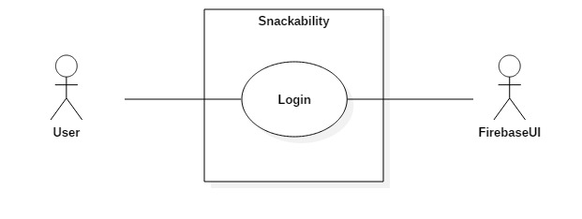

**Sequence Diagram**

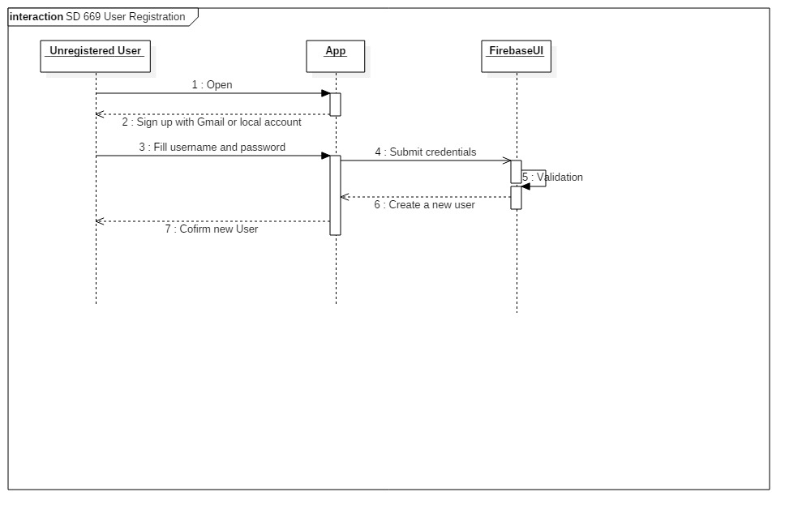

**Class Diagram**

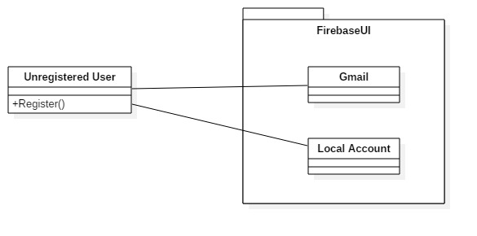

**Note:**

FirebaseUI is an open-source library that offers simple, customizable UI bindings on top of the core [Firebase](https://firebase.google.com/) SDKs. It aims to eliminate boilerplate code and promote best practices (both user experience and security) for authentication.

“Easily add sign-in to your Android app with FirebaseUI | Firebase.” *Google*, Google, firebase.google.com/docs/auth/android/firebaseui.

**Unit Test**

* Test case ID: user_reg_gmail_account_ID
* Description/Summary of Test: Given a real gmail username and password, when the user make a login with google selection, then the server should return the search page
* Pre-condition: User must have a gmail account
* Expected Results: Server should return the search page
* Actual Result: Search page returned
* Status (Fail/Pass): Pass
* Test case ID: user_reg_gmail_no_account_ID
* Description/Summary of Test: Given an incorrect gmail username and password, when the user make a sign in with google selection, then the server should return an error page
* Pre-condition: N/A
* Expected Results: Server should return the error page
* Actual Result: Error page returned
* Status (Fail/Pass): Pass
* Test case ID: user_reg_local_account_ID
* Description/Summary of Test: Given a username and password, when the user make a sing in selection, then the server should return the search page
* Pre-condition: N/A
* Expected Results: Server should return the search page
* Actual Result: Search page returned
* Status (Fail/Pass): Pass

**Integration Test**

**Visual User Guide** <like one or two screenshots of the feature. For the hardware project, a photo of device is required>